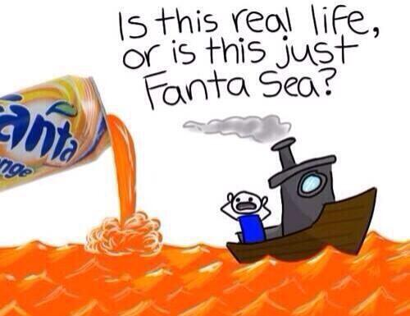
Poetry Terms and Devices

English 11
Most poetry can be looked at in two ways:
- Literal Meaning
- Implied Meaning

Both ways of looking at poetry are valid and useful. It is a combination of the two that help a student to deconstruct the poem and therefore be able to discuss and write about it. Your emotional response and your guesses are as useful to understanding the poem as your knowledge of language. Be brave!

Five things you can ask yourself to begin a Literal Interpretation of a poem.

- Who is the speaker?
- Who is the speaker talking to? (audience)
- What do all the words mean?(connotation, denotation, figurative language)
- What is going on in the poem? What does it mean, line by line?
- What is the structure of the poem? (rhyme scheme, free verse, blank verse, couplet, sonnet…)

Implied interpretation is when the reader understands a meaning that is less obvious. The reader senses or sees meaning that is contained within the poem. This is meaning that is not stated as fact, but instead only hinted at.

Getting at the implied meaning of a poem can be difficult, but there are a few things you can do that make it easier:

- Understand the literal meaning first.
- Use the emotional part of your brain to sense what the speaker in the poem might be saying indirectly.
- Use the clues in the poem to make a guess about what the subject of the poem is.
- Understand changes in time and place, shifts in tense and voice as possible clues.
- Examine symbols, metaphors and similes.
- Look closely at imagery, personification and look up possible allusions.
- Guess and then check your guess against the whole poem. For example, you might say. “I think this poem is about a volcano.” So, go back and read it again, looking at all the parts of the poem, the words, and the imagery. Ask yourself if your guess makes sense. As yourself if another guess might be better.
- Examine the associations you make with the words in the poem. (Connotations)
Form – Internal and Overall

The internal structure of a poem determines its classification of overall form.

(For example, a poem written in blank verse with a distinct melodic quality that is meant to be sung, would likely be classified as a ballad.)

Terms to talk about internal form:

Chorus (Refrain) – line or lines repeated at intervals during a poem or music

Couplet – two successive lines of rhyming verse with the same length

Internal Rhyme – rhyme that occurs within a single line

Whether Jew or gentile I rank top percentile – the Fugees

Repetition – repetition of sounds or phrases

Rhyme – repetition of similar or duplicate sounds at regular intervals

Rhyme Scheme – the arrangement of rhyme in a unit of verse

Rhythm – sense of movement of language due to stressed and unstressed syllables

Stanza – lines of poetry (verse) grouped to together, not unlike a paragraph

Verse – poetry, or lines of poetry

Terms used for Overall Form:

Ballad - a narrative poem, usually short and simple, originally intended to be sung

Blank Verse - unrhymed iambic pentameter

Free verse - verse lacking end rhyme, regular rhythm, or regulated stanza and line length. Instead it relies on natural speech rhythms

Monologue - an extended speech by one person
Soliloquy - an extended speech (monologue) in which a character alone on stage expresses his thoughts

Sonnet - a lyric poem consisting of fourteen lines, usually with a complicated rhyme pattern

Figurative Devices – appeal to the mind

Allusion – brief reference to a presumably famous person, place or event

Hyperbole – purposeful exaggeration ex. So hungry I could eat a horse

Imagery (Image) – vivid details create a picture in the mind of the reader

Metaphor – a comparison of one abstract idea to another

Oxymoron – placing to opposing ideas directly beside each other ex jumbo shrimp

Personification – giving human qualities to an inanimate object

Pun – a play on words that often uses one word with two meanings to create a
humorous effect

“Did you hear about the guy whose whole left side was cut off? He's all right now.”

Rhetorical Question – a question whose answer is already known and therefore no answer is required

Simile – a comparison using like or as

Symbol – wherein one idea represents another ex. Symbol=dove

Aural (Sound) Devices – appeal to the ear

Alliteration – a special type of consonance showing a close repetition of initial consonant sounds

Assonance – repetition of vowel sounds anywhere within a line

Consonance – the repetition of identical or similar consonants in neighbouring words whose vowel sounds are different ex. Hot foot, coming home, flip flop

Onomatopoeia – words that sound like their meaning ex. Splash

Repetition – repeated sounds, words, phrases or lines

