Novel Study
In the Skin of a Lion
By Michael Ondaatje

The PDF version of the book can be found as a link on my website:
Cristinaherman.weebly.com (under English 12)

Reading Schedule:

Chapter | Read By | Notable Features of section:
Book 1 – Chapter 1
Little Seeds
Book 1 – Chapter 2  The Bridge | January 3rd
Book 1 – Chapter 3  The Searcher | Jan 6
Book 2 – Chapter 1  Palace of Purification | Jan 13
Book 2 – Chapter 2  Remorse | Jan 20
Book 3 – Chapter 1  Caravaggio | Jan 27
Book 3 – Chapter 2  Maritime Theatre | Feb 3

Annotations

As you read, you will need to note features/sections that pertain to any of the following areas of analysis that you see as important. You may not write in the novel, but instead are encouraged to acquire multi-coloured sticky page markers that you can colour code. This will make finding quotations and support much easier when it comes to writing about the story.

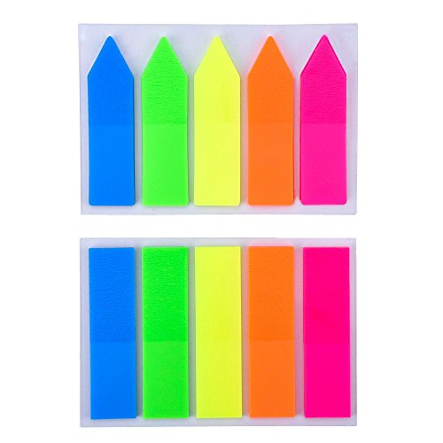
Features to look for:
- Characterization – direct and indirect
- Theme
- Setting
- Conflict
- Symbol
- Irony

